

DayFeel: Your Day, Your Feelings - A Web Application for Mood Check-ins, Private Reflection, AI-Assisted Conversation, and Moderated Peer Connection.
1. Statement of the problem
People who want to understand their day-to-day emotions may record feelings inconsistently or keep them across disconnected notes, chats, and calendars. This makes it difficult to look back at changes over time, connect a difficult day to its context, or maintain a regular reflection habit. Seeking peer support also introduces privacy and moderation concerns: users need ways to connect without publicly exposing their private journals or account details.
DayFeel addresses these workflow problems by bringing mood recording, journaling, reflective conversation, and moderated community interaction into one application. Its problem statement is a design premise; this documentation does not claim that a user study or clinical evaluation has established the application's effectiveness.
Issue | Application response
Inconsistent emotional tracking | A daily check-in with a consistent five-emotion scale, date-based history, charts, and a monthly calendar.
Limited context behind a mood score | Private journal entries allow users to record experiences and associated feelings.
Difficulty noticing recurring patterns | Historical summaries and weekly insights organize recorded data for reflection.
Desire for conversation and peer connection | An AI companion and member-only circle feeds and live chat provide separate ways to engage.
Privacy and harmful community interactions | Ownership checks, aliases, circle membership, reporting, moderation restrictions, and account data controls.
2. Application Premise and Objectives
The developer of the application chose the name DayFeel as a wordplay on “They Feel”. A phrase that acknowledges that everyone has feelings and that those feelings deserve to be recognized. The name reflects the intention to create a space where users can express what they are experiencing without feeling dismissed or judged.
Changing “They” to “Day” connects that idea to the application’s daily check-ins. Each day can bring different emotions, and DayFeel encourages users to pause, acknowledge how they feel, and record their experiences. The name brings together emotional acknowledgment and the habit of daily reflection.
The developer chose yellow as the application’s main interface color because of the informal expression “yellow person” someone in your life who brings emotional safety, warmth, optimism, and comfort. This idea inspired the kind of experience I want DayFeel to offer. A welcoming place to check in, reflect, and feel heard.
The soft yellow palette expresses that intention through the interface. It is meant to feel warm and approachable while leaving room for sadness, anger, stress, and other difficult emotions. DayFeel does not ask users to feel happy every day; it invites them to acknowledge whatever they are feeling.
This is the design aspiration behind the brand, rather than a promise that a color or an application can guarantee emotional safety. DayFeel aims to support reflection and connection while complementing, rather than replacing trusted relationships and professional support.
The premise is that a low-friction space for regular check-ins and written reflection can help users organize their experiences and notice patterns in their own records. DayFeel presents these records in a calm interface and provides optional AI-assisted reflection. Community circles support shared discussion while keeping private reflection separate.
The primary objectives are to make daily recording straightforward, preserve a useful history, support reflection without diagnostic claims, provide moderated peer interaction, and give users control over AI preferences and account data.
DayFeel supports wellbeing and self-reflection. It is not a diagnostic tool, treatment service, emergency service, or replacement for professional care. “Need help now?” links directly to Find A Helpline; DayFeel does not operate that external service.
3. Scope of the application
Users and roles
- Member: manages a profile, records check-ins, writes journals, uses the companion module – a chat bot that can help you with self-reflections, joins circles, interacts with community content, and reports other members' posts or comments.
- Moderator: reviews reported content within authorized circles; pauses posting, restricts access, restores access, or removes reported content.
- Administrator: accesses administrative features such as circle creation. Admin can also do the moderation roles.
Implemented User-Facing Capabilities
- Registration, sign-in, session handling, profile aliases, avatar upload.
- Daily mood check-ins, historical ranges, a check-in table, and a monthly calendar. Journal entries and check-ins are separate records.
- Private journal creation, editing, deletion, and paginated reading.
- Companion conversations with persistent messages, first-message titles, manual renaming, deletion, and optional contextual memory.
- Circle membership; newest-first posts and comments; supportive reactions with saved selections and counts.
- Circle live chat with the latest 50 saved messages, older-message pagination, timestamps, and distinct sender bubbles.
- Post and comment reporting, self-report prevention, moderator content previews, and time-limited restrictions.
- Weekly insight storage and retrieval, with scheduled generation dependent on configuration and AI availability.
- Privacy export and deletion workflows; direct external support links.
Boundaries and Known Limitations
The application does not provide clinical diagnosis, appointments, professional messaging, payment processing, or emergency dispatch.
4. High Level Diagram
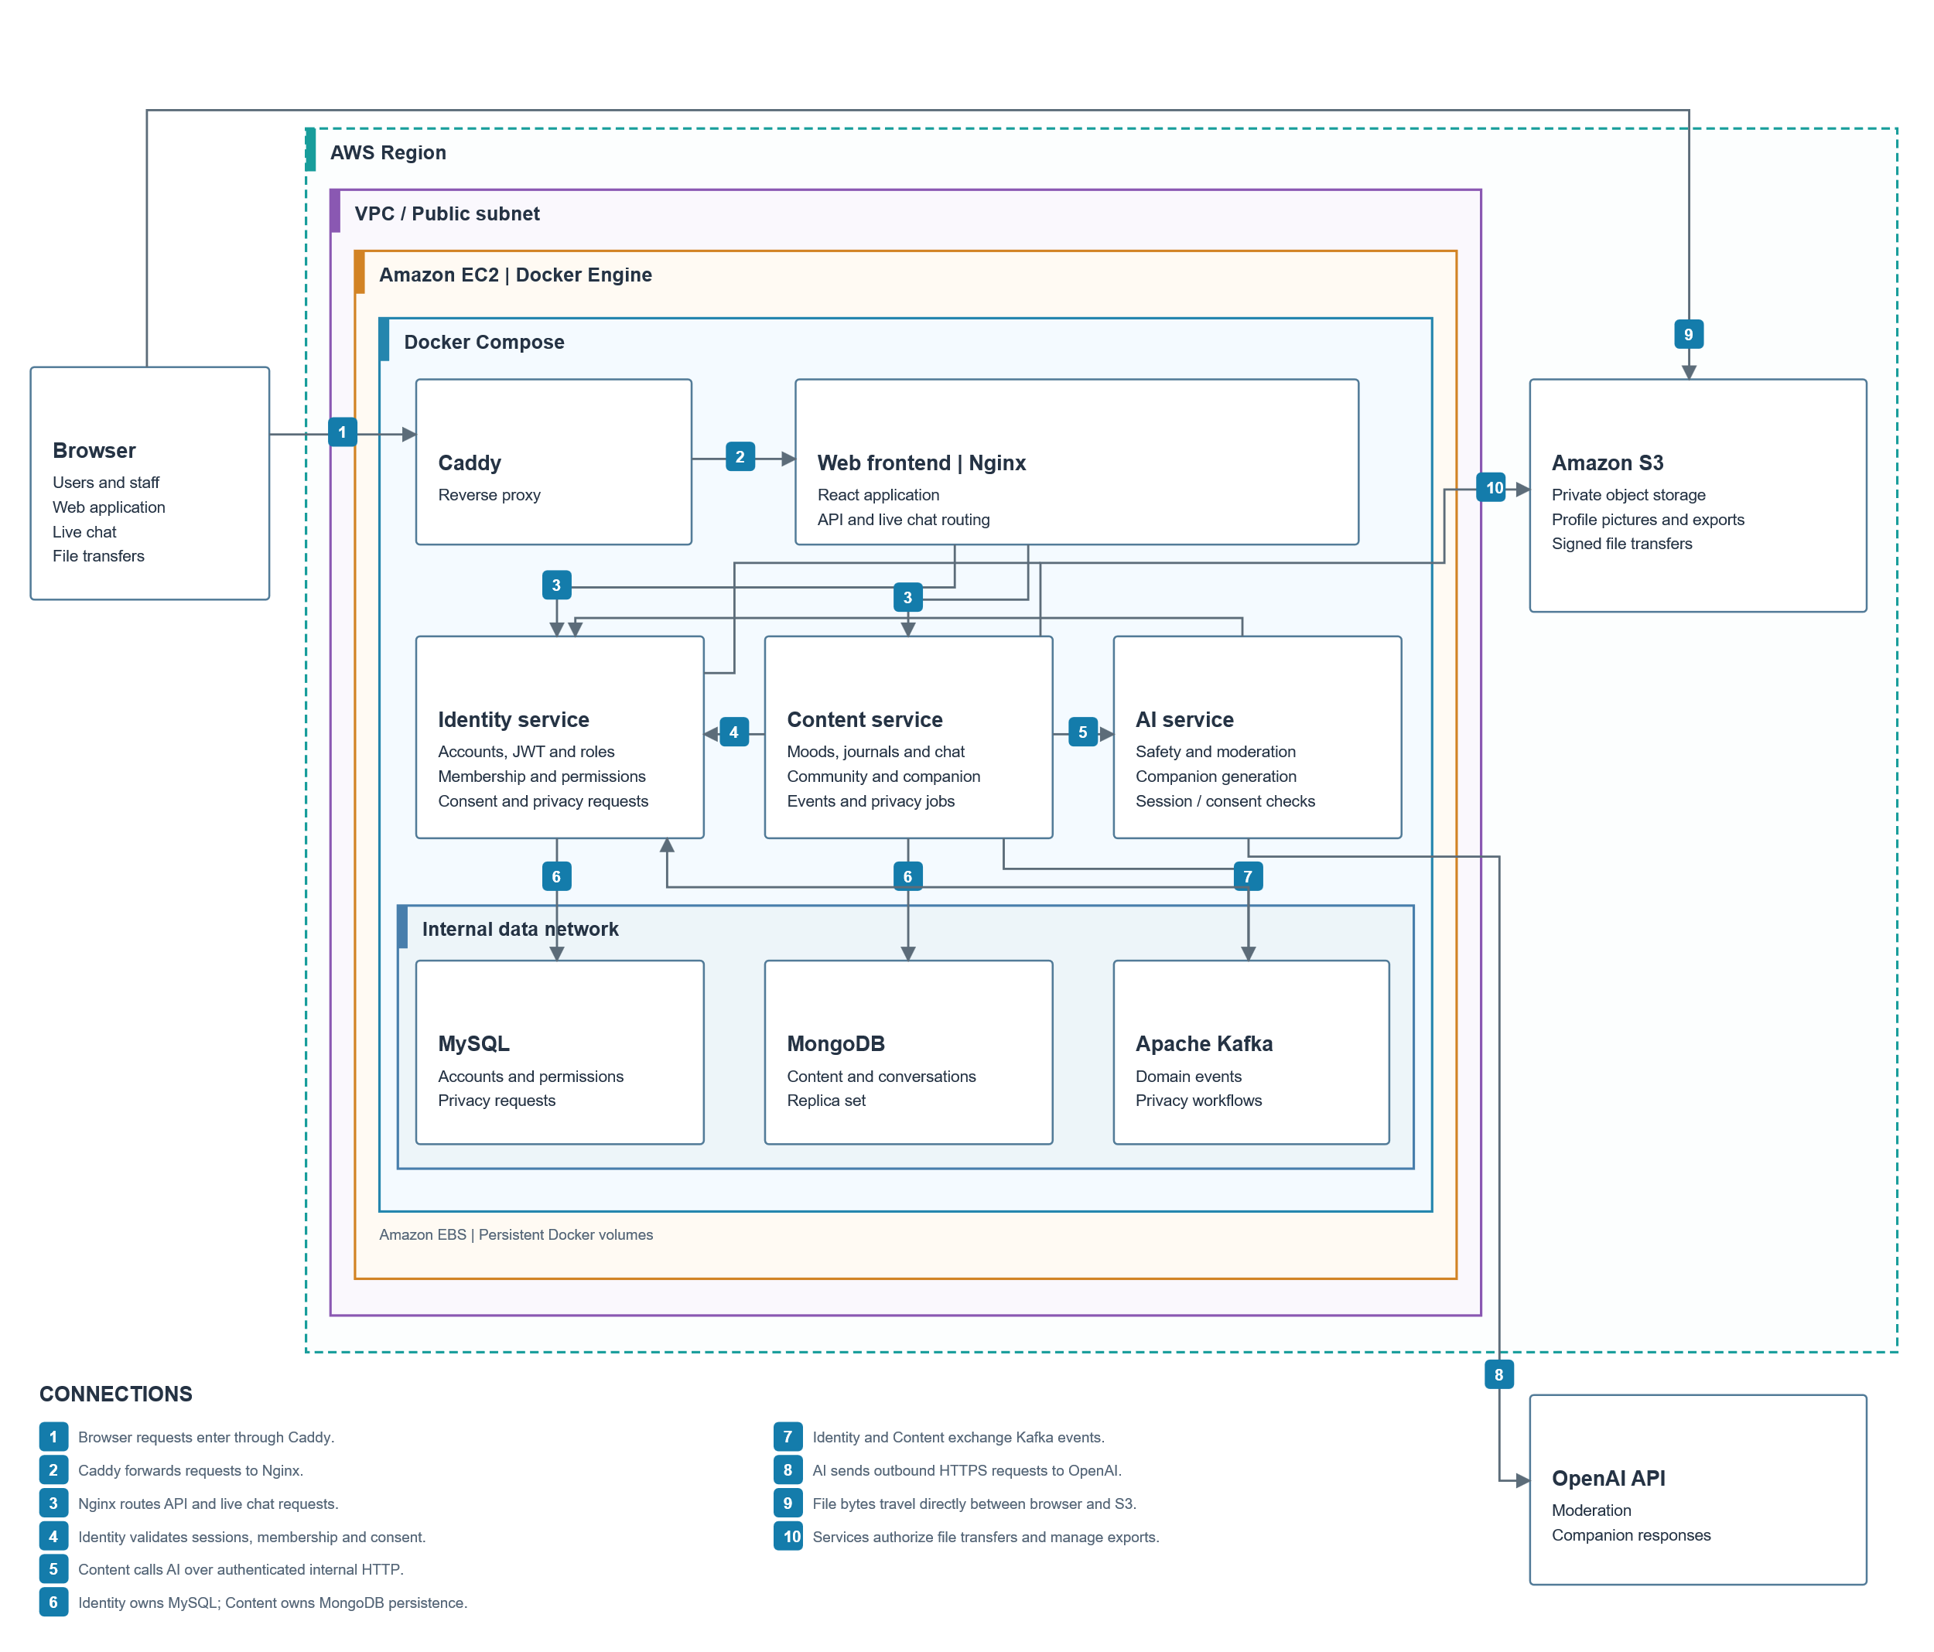
5. Technology Stack
Layer | Technology | Purpose
Browser interface | React 18, TypeScript, Vite 6, CSS and Tailwind CSS 4 | Component-based screens, typed client code, responsive styling, local build and development server.
Frontend state and networking | React Router 6, TanStack Query 5, Zustand 5, Axios, Socket.IO client | Routing, remote-data caching and pagination, session/UI state, HTTP requests, and live chat.
Identity backend | Java 21, Spring Boot 3.3.13, Maven, Spring Security, Spring Data JPA, Flyway | Authentication, authorization, relational transactions, persistence, and versioned SQL migrations.
Content backend | Node.js 20 target, TypeScript, Express 4, Mongoose 8, Zod, Pino | Content APIs, MongoDB access, input validation, structured logging, and background processing.
AI backend | Python 3.11 target, FastAPI, Pydantic, Uvicorn, HTTPX, OpenAI Python SDK | Internal AI endpoints, validated provider requests/responses, and language-model integration.
Persistence | MySQL 8; MongoDB replica set | Relational identity/policy records and document-oriented private/shared content. MongoDB transactions require replica-set support.
Messaging and realtime | Apache Kafka, Spring Kafka, KafkaJS, Socket.IO | Asynchronous domain events and jobs; authenticated live circle messaging.
Object storage | Amazon S3; AWS SDKs for Java and JavaScript | Private avatar/content files and generated exports with temporary signed upload/download URLs.
API contracts | OpenAPI, Swagger UI, openapi-typescript | Reviewable service contracts, interactive API documentation, and generated frontend types.
Verification | JUnit, Mockito, Testcontainers; Jest, Supertest, MongoDB Memory Server; Vitest, Testing Library, Playwright; pytest | Unit testing for service, authorization, integration, component, browser, and AI adapter testing.
5. Architecture and Microservice Responsibilities
5.1 Identity service
Owns account identity and authorization policy. It manages users, passwords, roles, sessions, public aliases, AI consent, circle definitions and membership, reports, moderation actions, and privacy request status. It issues signed JWTs and exposes public signing keys through JWKS so other services can validate tokens.
MySQL provides relational constraints and transactional updates for these records. A transactional outbox records domain events for publishing to Kafka. Identity also coordinates avatar storage URLs and access to completed exports. It does not store private journal or companion message text.
5.2 Content service
Owns journal entries, mood logs, companion history, posts, comments, reactions, chat messages, weekly insights, file metadata, and processing state. It validates ownership and asks Identity for current membership, consent, and restrictions before protected actions.
5.3 AI service
Provides internal endpoints for companion replies serving as the AI chatbot of the application. It acts as a stateless adapter to OpenAI.
5.4 Frontend and Infrastructure Boundaries
Frontend is the browser client, not a separate data-owning backend. Its UI permissions improve usability, but backend checks enforce access. Kafka, MySQL, MongoDB, and S3 are infrastructure dependencies rather than additional application microservices. Vite proxies local API paths; it is not a production gateway.
5.4 Physical Architecture
DayFeel is a Dockerized application deployed on a single AWS EC2 instance. Docker Compose manages multiple containers, including Caddy and Nginx for web access and frontend hosting, Spring Boot for authentication and user management, Node.js for moods, journals, community features and live chat, and Python/FastAPI for AI-powered responses and content moderation. The application uses MySQL to store identity data, MongoDB for application content, and Apache Kafka for communication between services. Amazon S3 provides private file storage, while the OpenAI API supports AI functionality.
6. Data Ownership and Relationships
Store | Principal records | Relationship approach
MySQL / Identity | Users, roles, user-role assignments, refresh sessions, circles, memberships, reports, moderation actions, privacy requests, outbox events, processed events. | SQL foreign keys and application policy. Membership links a user to a circle and stores mute/ban expiry.
MongoDB / Content | Mood logs, journals, companion conversations/messages, posts/comments/reactions, chat messages, weekly insights, uploaded-file metadata, and event/privacy job state. | Document identifiers and application-enforced references. A comment references its post; a message references its conversation or circle.
S3 | Avatar files, content uploads, generated export objects. | Databases retain object keys or metadata; file bytes are stored in S3.
Cross-service user and circle IDs are logical references, not cross-database foreign keys. Account deletion, alias changes, and moderation therefore require coordinated processing. Event consumers use deduplication and state checks to reduce duplicate effects and prevent deleted data from being recreated.
See database purposes, relationship diagrams, and MongoDB dictionary for field-level details.
7. Principal Workflows
- Authentication: the browser submits credentials to Identity, receives tokens, and sends its access token to protected endpoints. Backend services verify tokens and enforce policy.
- Daily check-in: Content saves the authenticated user's mood for a local calendar date. Updating that day replaces its values rather than creating a second daily record. Range summaries and month calendars use different date filters.
- Journal: Content stores the private entry, screens the text, and queues eligible analysis work. Results are accepted only when consent and entry revision still match. The missing worker is a prerequisite for a complete automatic analysis pipeline.
- Companion: Content persists the user's message, performs safety checks, obtains an AI response when permitted, and persists the reply. Memory consent controls additional context; disabling it does not delete conversation history.
- Community: Identity validates membership and restrictions; Content stores moderated posts/comments and one current reaction per user and target. Circle chat loads history and merges incoming live messages.
- Reporting: a member selects a reason; Content resolves the author server-side and rejects self-reports. Identity stores the report. Authorized moderators view reported content and apply actions. Restrictions are checked on later requests, and events synchronize downstream state.
- Privacy: Identity records an export or deletion request. Content processes its owned records and storage objects and sends completion events. Identity updates request status. A request submission alone does not imply completion.
8. Proposed Future Enhancements
To further improve the DayFeel application, the following are enhancements are listed:
Enhancement | Purpose and completion criteria
AI Insights based on mood trends | Implement use of AI to provide insights of your moods based on a weekly/monthly basis. Suggest focus points on where you can work on and provide habits and activities to improve mood.
Notifications Module for DayFeel | Add notifications module where you can set a reminder for your daily check-ins. Alert when your post is being flagged or reported. Or a new message was sent in your circle.
Admin Module for Account Support | Provide forgot password functionality for existing users. Have an admin functionality to manage users including add/update/delete of users.
Chat privacy and retention policy | Define whether new members can view pre-join messages, retention duration, and deletion behavior. Implement only after those product rules are agreed.
AI evaluation and cost controls | Evaluate reply quality and safety behavior with repeatable test sets, version prompts/models, and add provider usage budgets without introducing unused consent controls.

